

**Capstone Project Phase B**

**NODUS - Childhood ADHD Symptom Detection with Possible Solutions**

**User Guide**

safwanhalabi60@gmail.com

bish.150b@gmail.com

# **Table of Contents**

**Table of Contents 2**

**Introduction 3**

**1. Preparation Pages 3**

1.1 Home Page 3

1.2 FAQ Page 4

1.3 Consent Form Page 5

1.4 Instructions Page 6

**2. Eye-Test Page 7**

**3. Vocal-Test Page 12**

**4. Questionnaire Page 15**

**5. Results Page 17**

# **Introduction**

In this book we will document and explain the flow of the Nodus system, detailing all the information that the user needs in order to use our product effectively.

We will divide this guide book into several sections, each detailing a core functionality of the system, along with the correct way to navigate and use it.

Alongside this guide book we also provide the user with a video guide showcasing the system, it can be found in the following link: [link to video guide](https://www.youtube.com/watch?v=bEg4kmK2Svg).

# **1. Preparation Pages**

In this section we will explain all the pages that precede the tests, how to navigate them and what the user is asked to do in order to gain access to the test pages.

This section covers the following pages: Homepage, FAQ, Consent Form, and Instructions.

## **1.1 Home Page**

The Homepage is the landing page where users first interact with the system. It provides an introduction to the Nodus System, outlining its purpose and guiding users through the initial steps, this is what the page looks like:

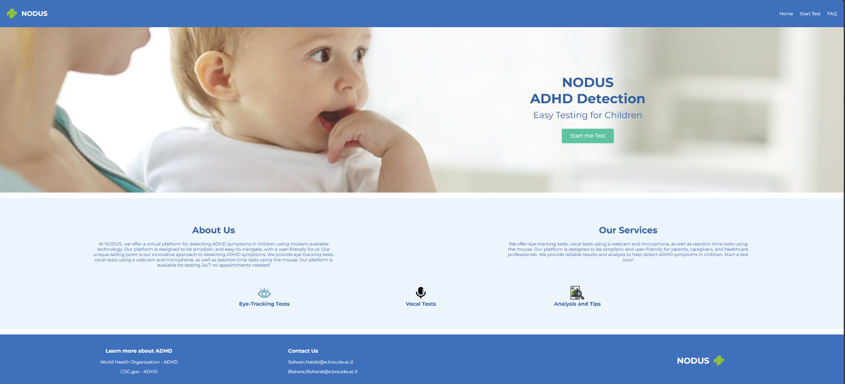

Input Fields and Actions:

* **Start Test Button:** This button directs the user to the Consent Form page. Clicking this button initiates the testing process.
* **Navigation Links:** Users can navigate to other sections such as the FAQ or Contact pages using these links.

Requirements:

The user does not need to input any information on the Homepage, but they must click "Start Test" to proceed.

## **1.2 FAQ Page**

The FAQ Page contains answers to the most common questions regarding the system. Each question is collapsible, allowing the user to view detailed explanations as needed, this is what the page looks like:

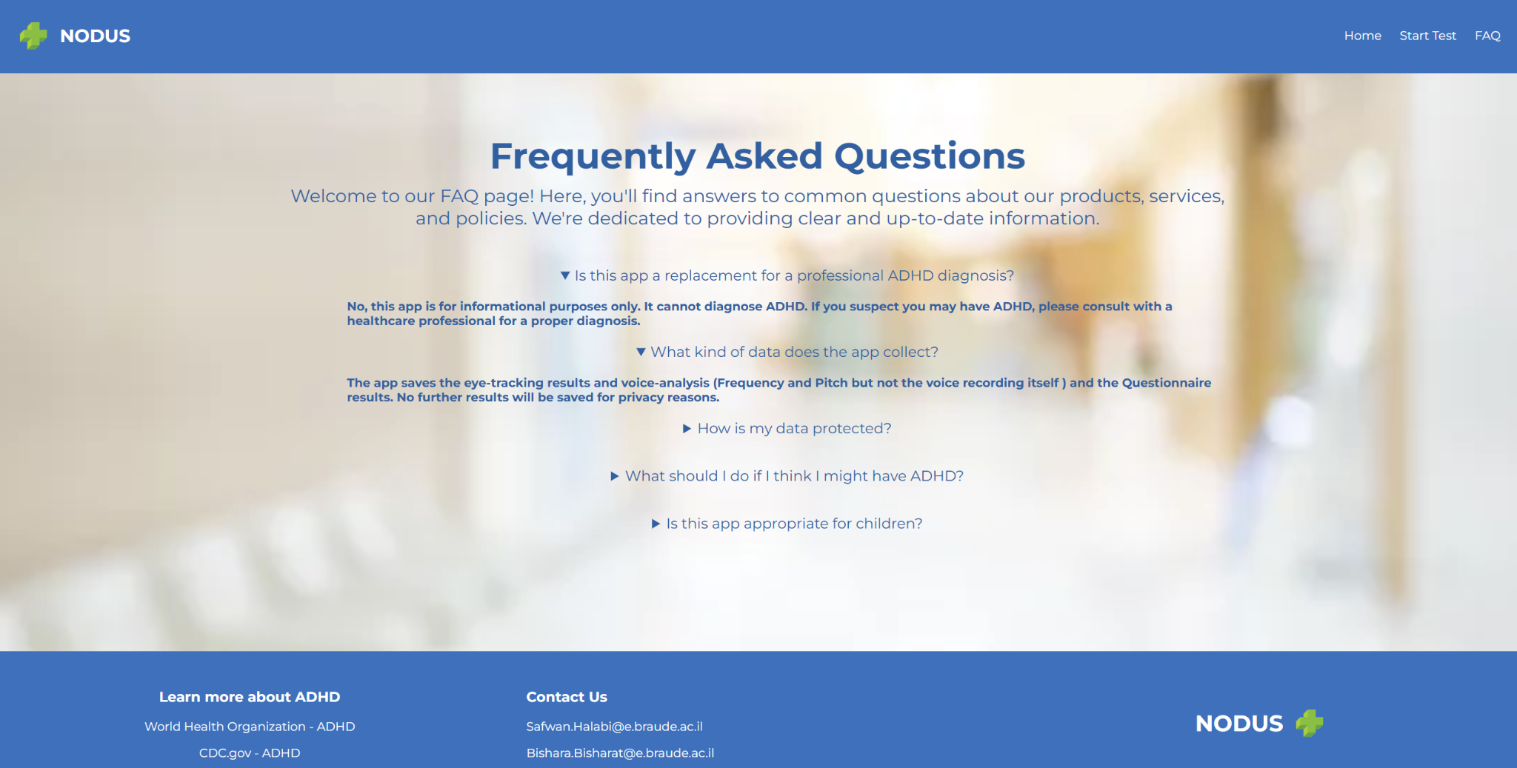Input Fields and Actions:

* **Question Tabs:** Clicking on a question expands it, revealing the answer. Users can click again to collapse it.

Requirements:

No specific input is required from the user; this page is informational only.

## **1.3 Consent Form Page**

The Consent Form page is a mandatory step where the user must agree to participate in the study. The form outlines the study’s purpose, procedures, risks, and the user’s rights, here is what the page looks like:

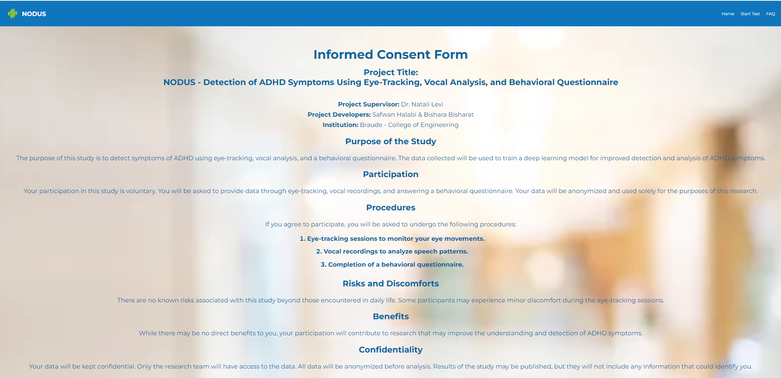

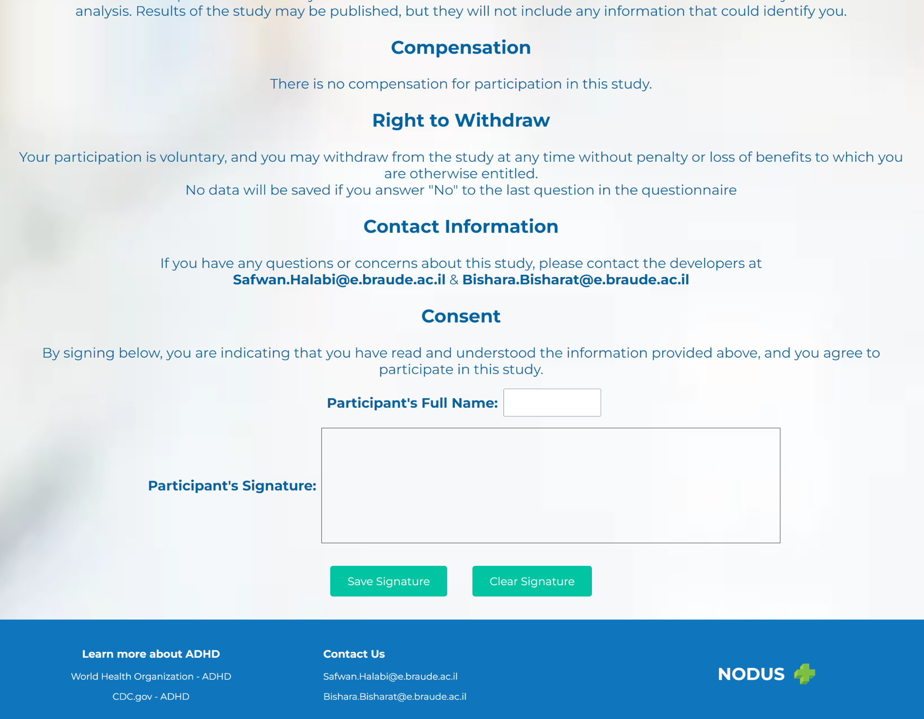

Input Fields and Actions:

* **Full Name:** The user must enter their full name as a digital signature.
* **Digital Signature:** The user provides their signature to agree to the terms.
* **Agree and Continue Button:** This button submits the consent and allows the user to proceed.

Requirements:

The user must provide accurate and complete information. The system will not proceed without a valid name and signature.

## **1.4 Instructions Page**

The Instructions Page provides detailed guidance on how to complete each part of the test. It ensures that the user understands how to interact with the system correctly, this is what the page looks like:

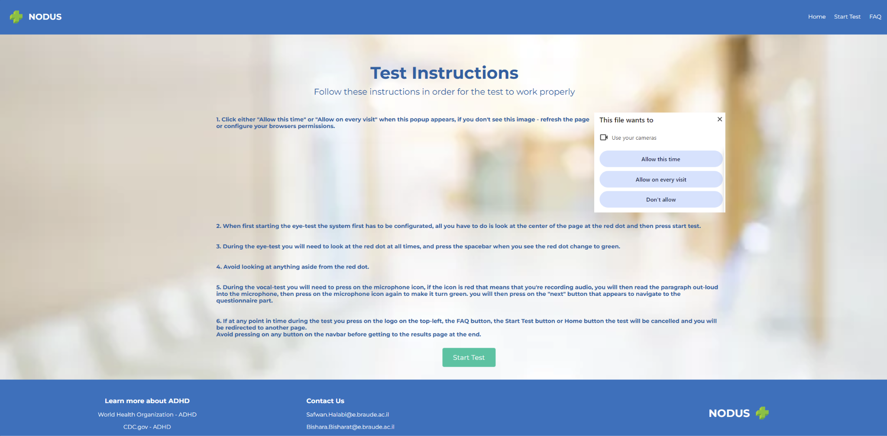

Input Fields and Actions:

* **Instructions Text:** The user must read and understand the instructions provided.
* **Start Test Button:** Once the user has reviewed the instructions, they click this button to begin the test.

Requirements:

The user must click "Start Test" to initiate the first task.

# **2. Eye-Test Page**

The Eye-Test Page is the first of the three main tasks in the system. It involves tracking the user's eye movements while they focus on a red circle displayed on the screen, there are instructions for this specific page on the screen, here is what the initial page looks like:

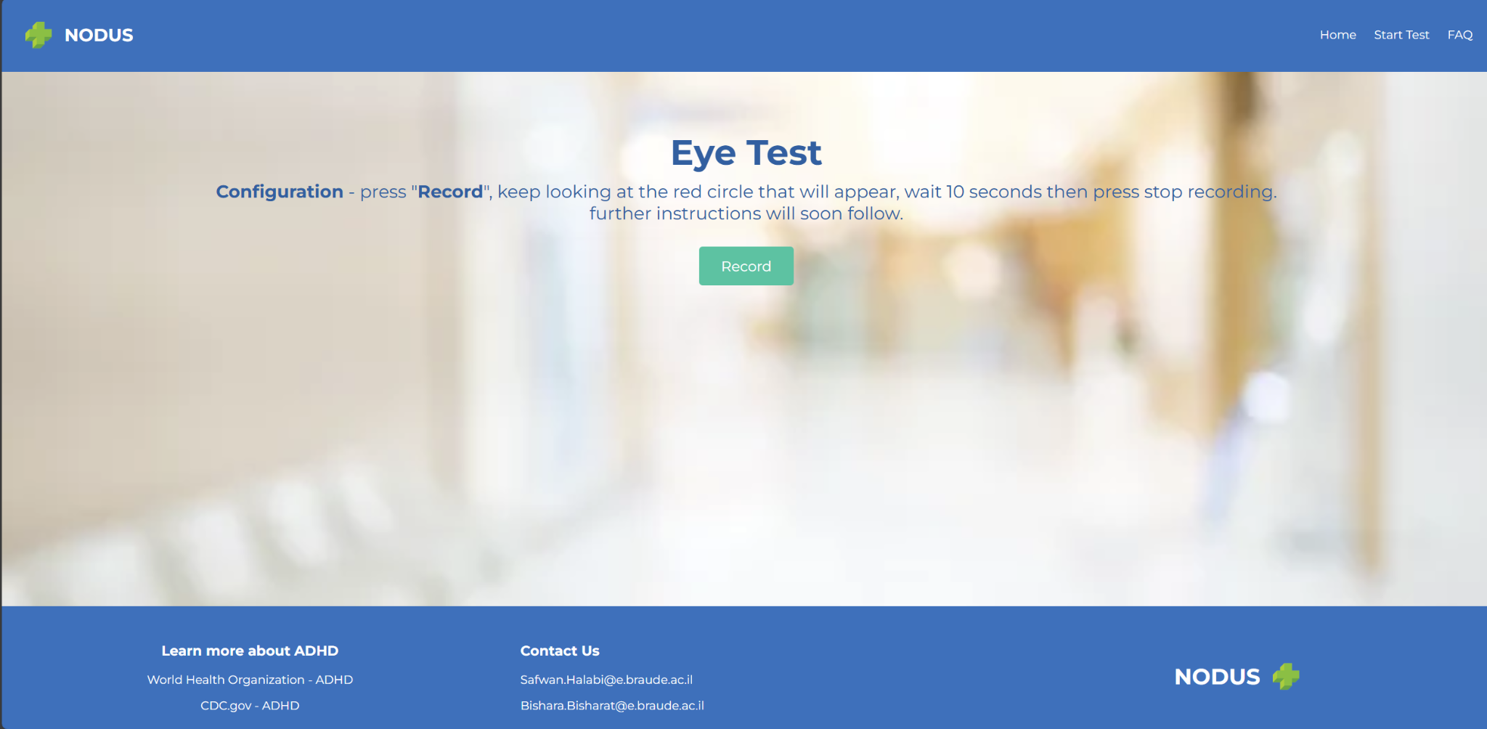

When the user first accesses this page he will be asked to start recording by pressing the “Start Recording” button, look at the red dot for about 15 seconds and then manually press the “Stop Recording” button to stop recording.

A permission prompt will pop up once the user presses “Start Recording”, the user will have to accept the prompt, here what the page will look like then:

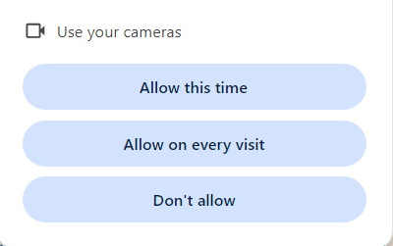

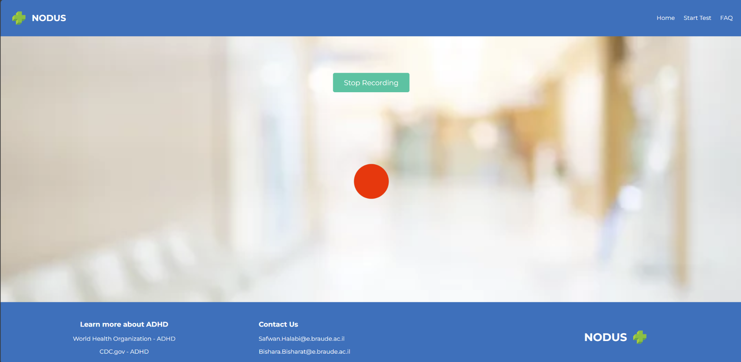

After which the user will be asked to wait a couple of seconds for the server to analyze the video feed the user sent, if the server recognizes the eyes of the user he will get a new prompt with new instructions to the actual test.

Here is what the page with the new prompt looks like:

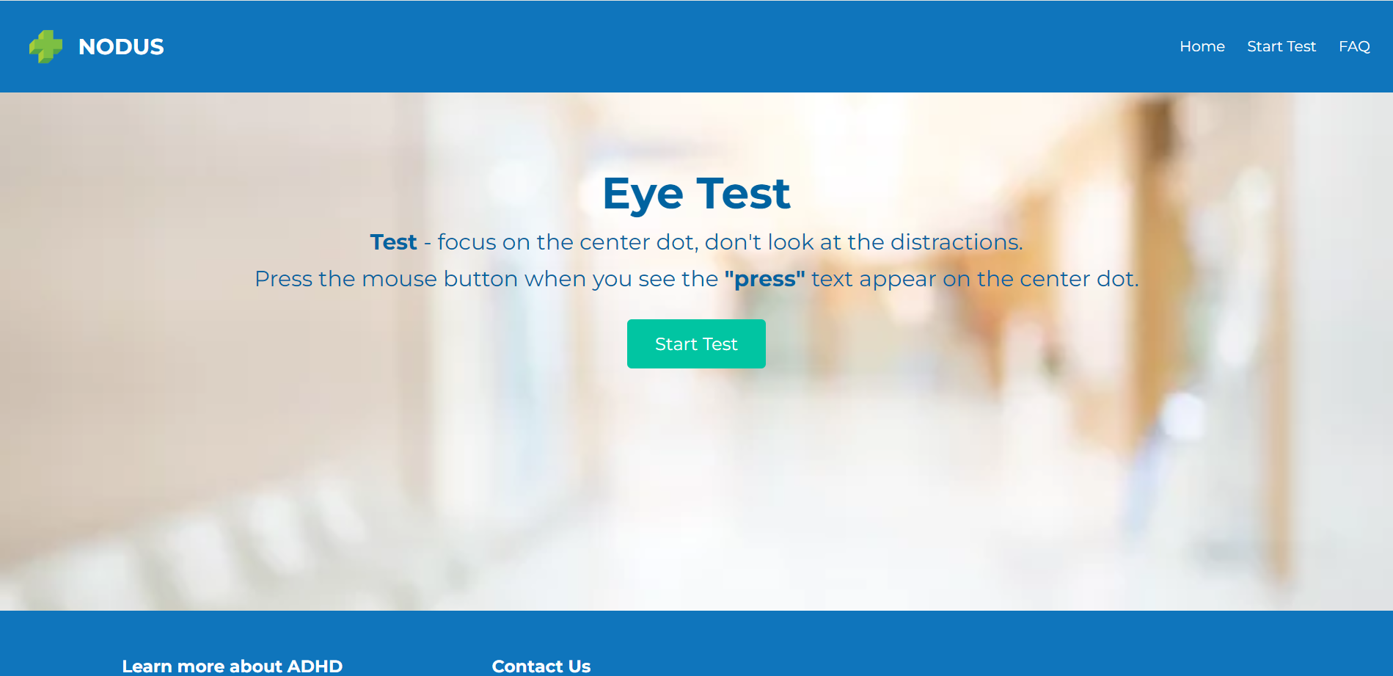

The test starts once the user press the “Start Test” button, the user will then be greeted with the same page he saw in the initial check, however now there is no need to manually stop recording as the test does that all by itself, the user will be asked to stare at the circle in the center of the page and occasionally press the mouse button if the word “press” appears in the middle of circle, nothing more.

The test ends automatically after 2 minutes, here is an image of the test:

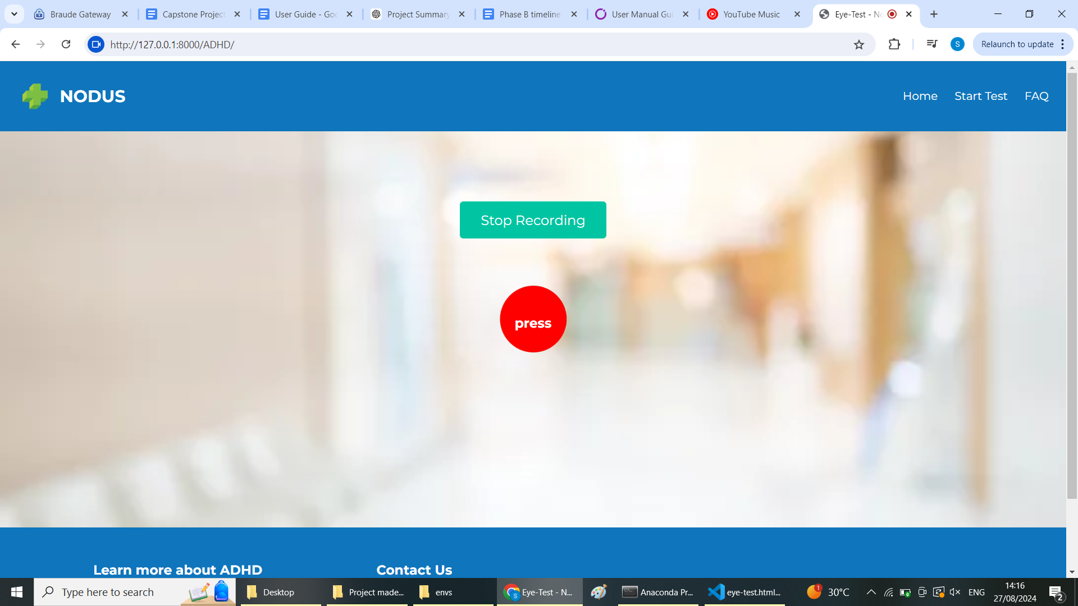

When all is said and done, the user will be greeted to a new page with instructions that states “Sending video to server, you will be redirected to the next page shortly”, here is what the page will look like then:

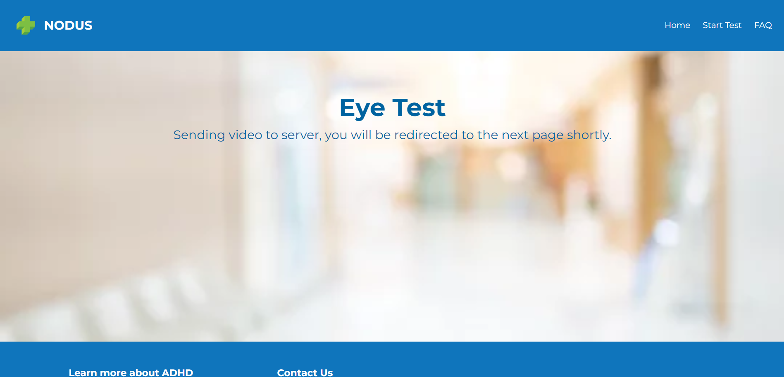

Input Fields and Actions:

* **Calibration:** Before starting, the user is prompted to focus on the red circle for calibration purposes.
* **Focus:** The user must keep their eyes on the red circle throughout the test.
* **Reaction Time:** When the word "press" appears, the user must quickly click the mouse button.
* **Distractor Phase:** In the second phase, the system introduces visual and auditory distractors, but the user must continue focusing on the red circle.

Requirements:

The user must maintain focus on the red circle and respond promptly to the "Press" prompt. Any deviation may affect the test’s accuracy as it is treated as an ADHD symptom.

# **3. Vocal-Test Page**

The Vocal-Test Page is the second main task in the system, designed to analyze the user’s speech patterns. The system records the user’s voice as they read a series of sentences displayed on the screen. This task is crucial for assessing vocal characteristics that may indicate symptoms of ADHD.

Upon reaching this page, the system will request access to the user’s microphone. The user must grant permission for the microphone to be used. If the permission request is denied, the user will not be able to proceed with the test, and the system will prompt them to enable microphone access, this is what that looks like: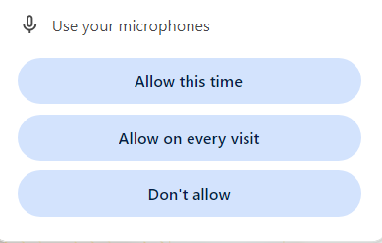

After granting microphone access, the user will see a green button with a microphone logo on it. Once the user clicks this button, the system will begin recording their voice. The recording interface will display a list of sentences for the user to read aloud.

The user should read each sentence clearly and at a steady pace. The sentences are designed to cover a range of speech patterns, so it is important that the user speaks naturally without rushing, this is what the page will look like then:

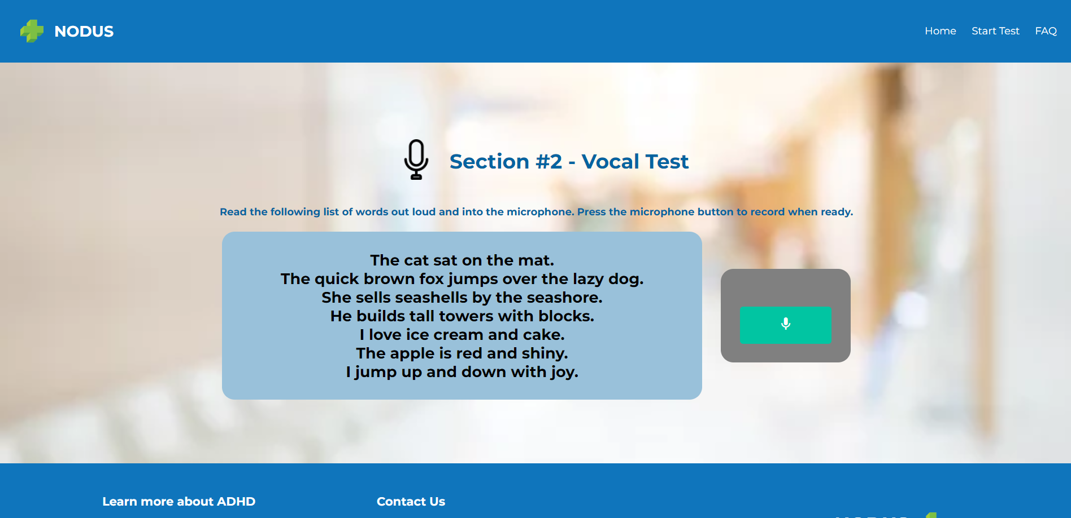

This is what the page will look like when the user starts recording audio:

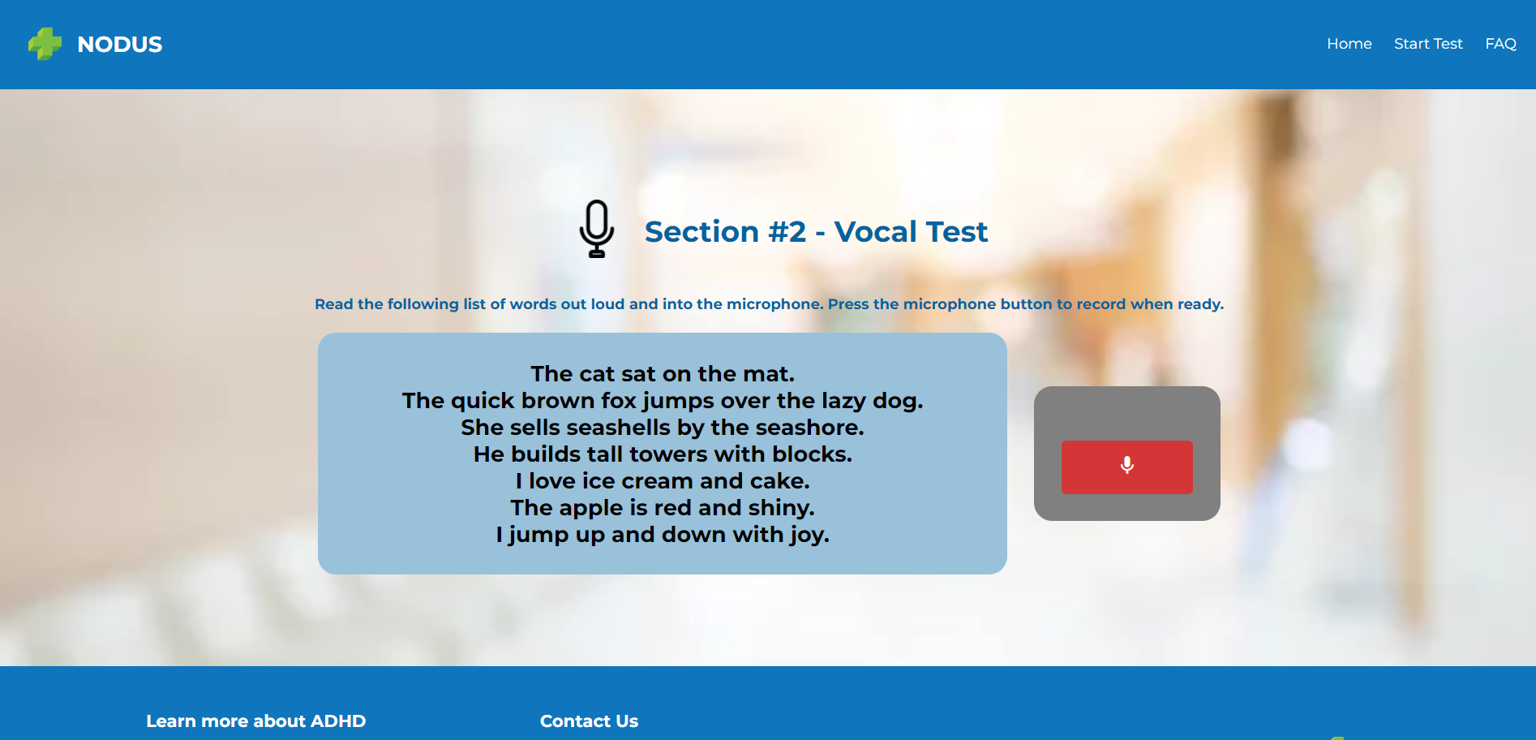

Notice how the microphone button turned red.

Once the user has finished reading all the sentences, they must click the “Stop Recording” button. The system will then show a button labeled “Next”, when the user presses it the audio-recording will be sent to the backend automatically, no prompt is shown to the user at this time and the page will redirect them automatically when the audio recording is saved successfully in the backend, here is what the page will look like then:

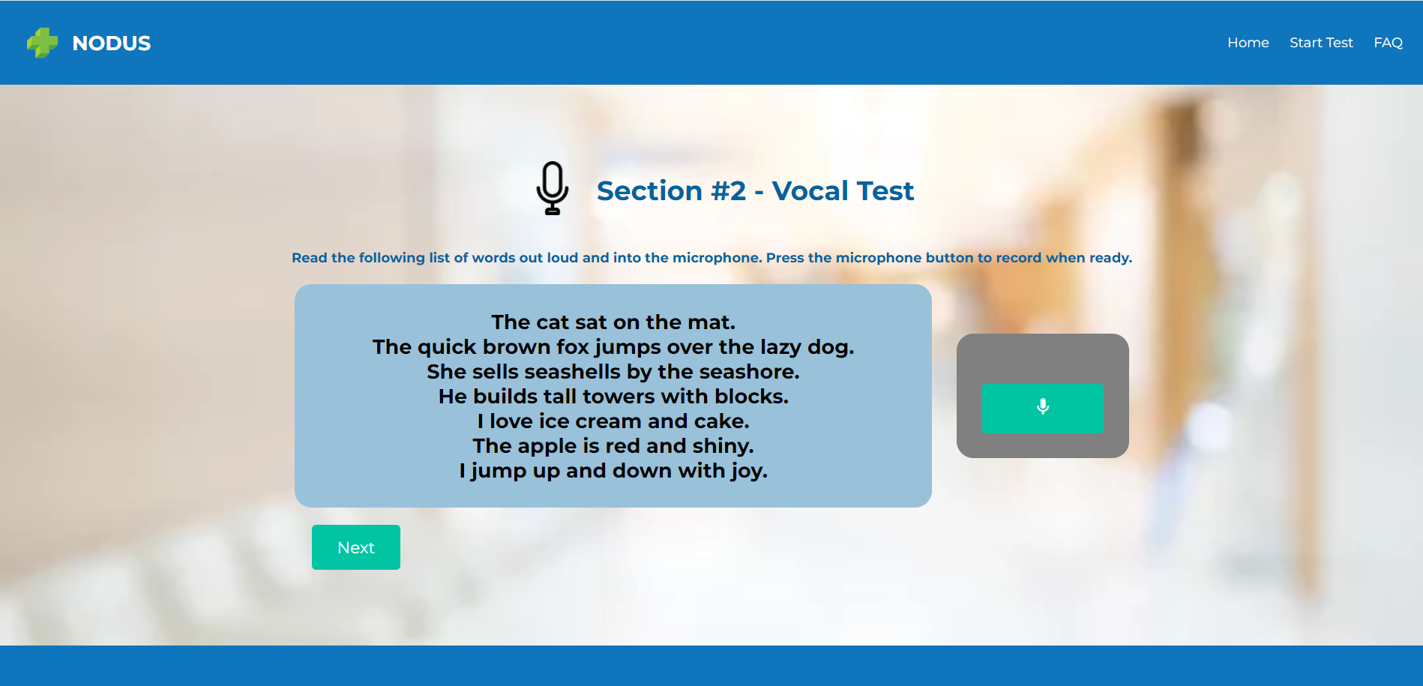

**Important Note:** If the user stops the recording too early or the audio quality is poor, the system may prompt them to repeat the task to ensure accurate data collection.

Input Fields and Actions:

* **Start Recording Button:** Initiates the recording of the user’s voice.
* **Stop Recording Button:** Ends the recording and sends the data to the server for analysis.
* **Microphone Permissions:** Required to access the microphone and record the user’s voice.

Requirements:

The user must speak clearly and read all the sentences displayed. Any hesitation, unclear speech, or poor audio quality may affect the accuracy of the analysis.

# **4. Questionnaire Page**

The Questionnaire Page is the final task in the Nodus System. It consists of 20 questions designed to assess the user’s behavioral tendencies, focusing on aspects that are commonly associated with ADHD. The responses provided by the user are a critical component of the overall evaluation.

At the beginning of the page the user will find an introduction to this page along with instructions.

Aside from that the questionnaire is divided into 4 distinct parts: questions about inattention symptoms, questions about hyperactivity symptoms, question about impulsiveness symptoms and 2 general questions at the end, here what the start of the questionnaire looks like: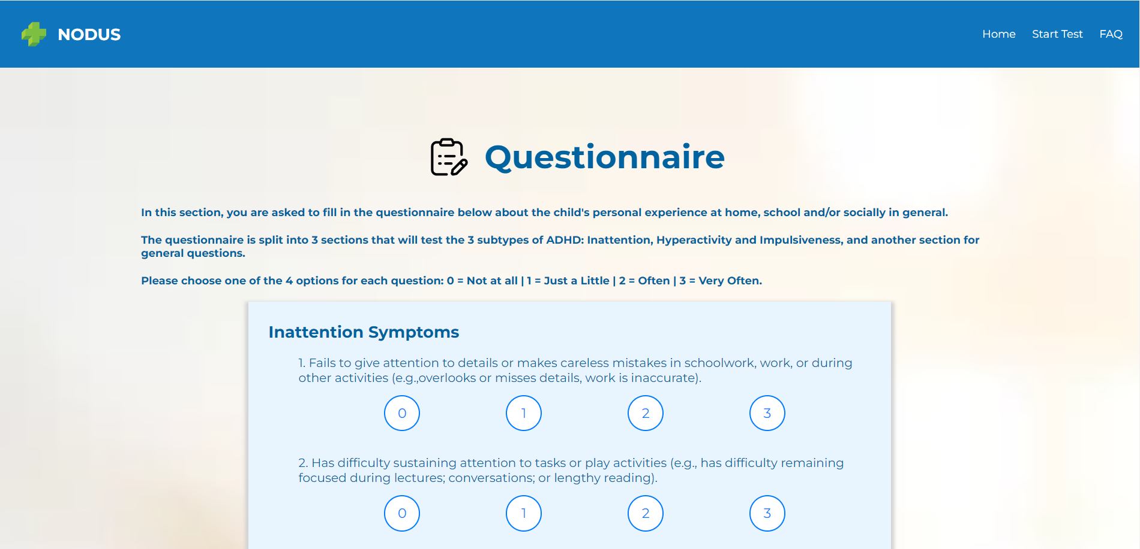

Here what the hyperactivity symptoms section looks like:

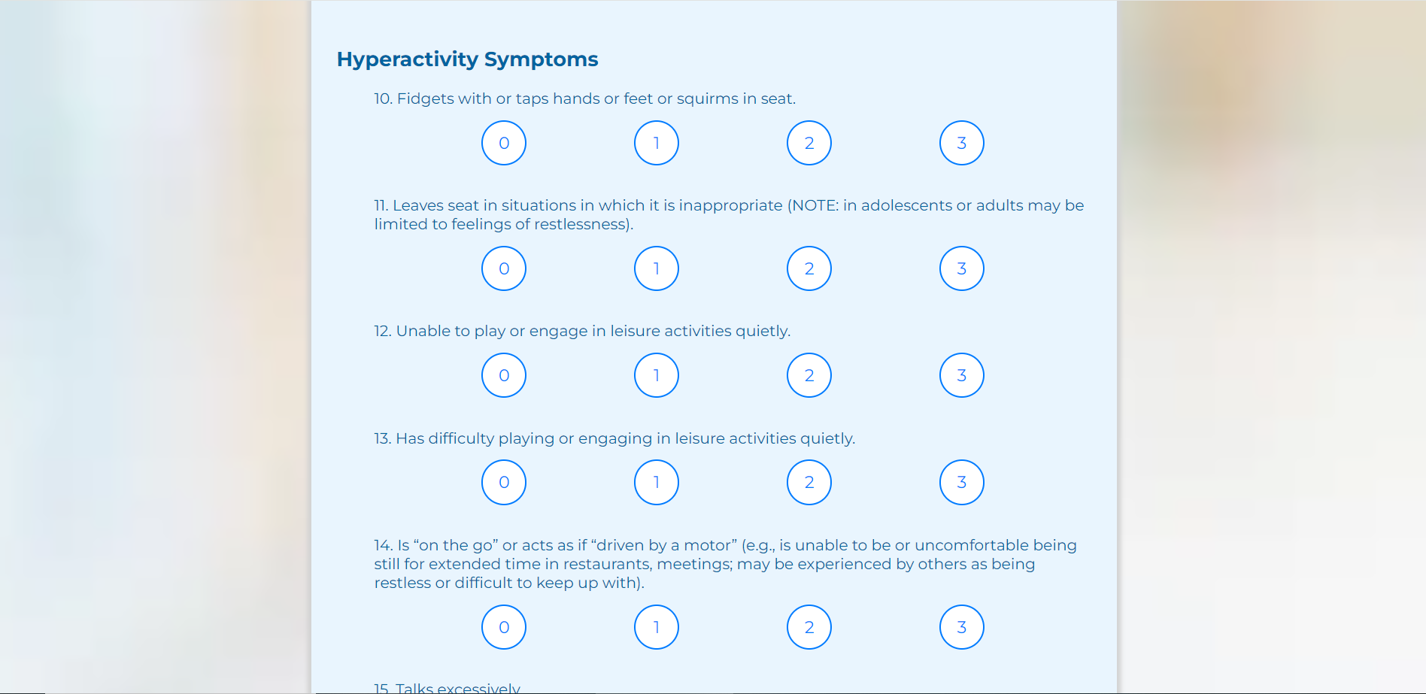

Here is what the impulsiveness symptoms section looks like:

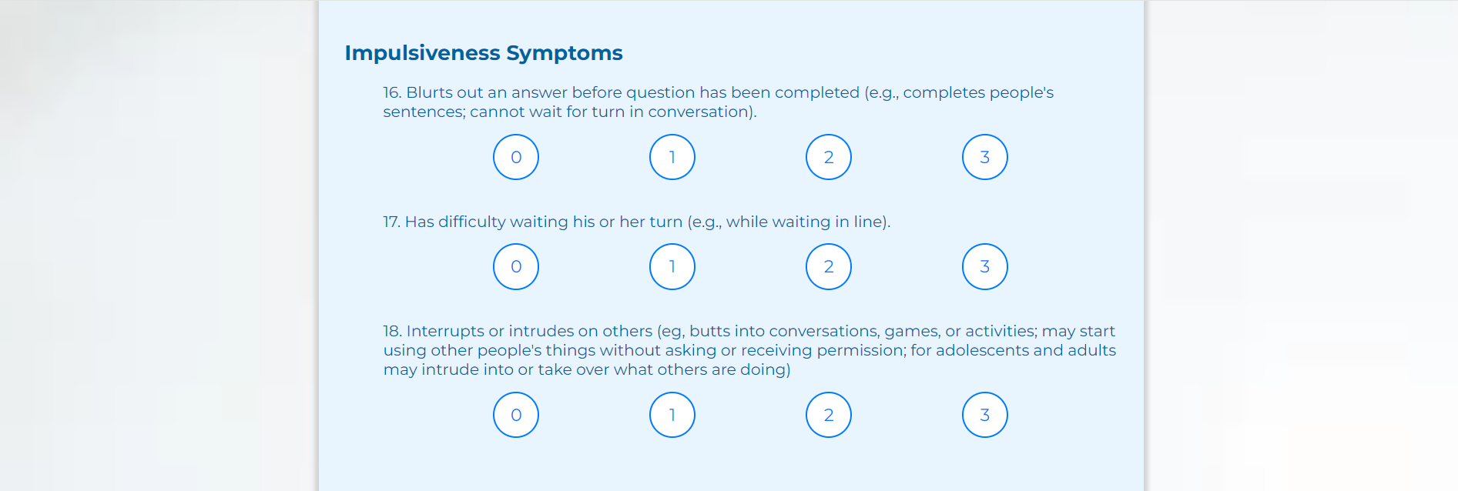

Here is what the general questions section looks like:

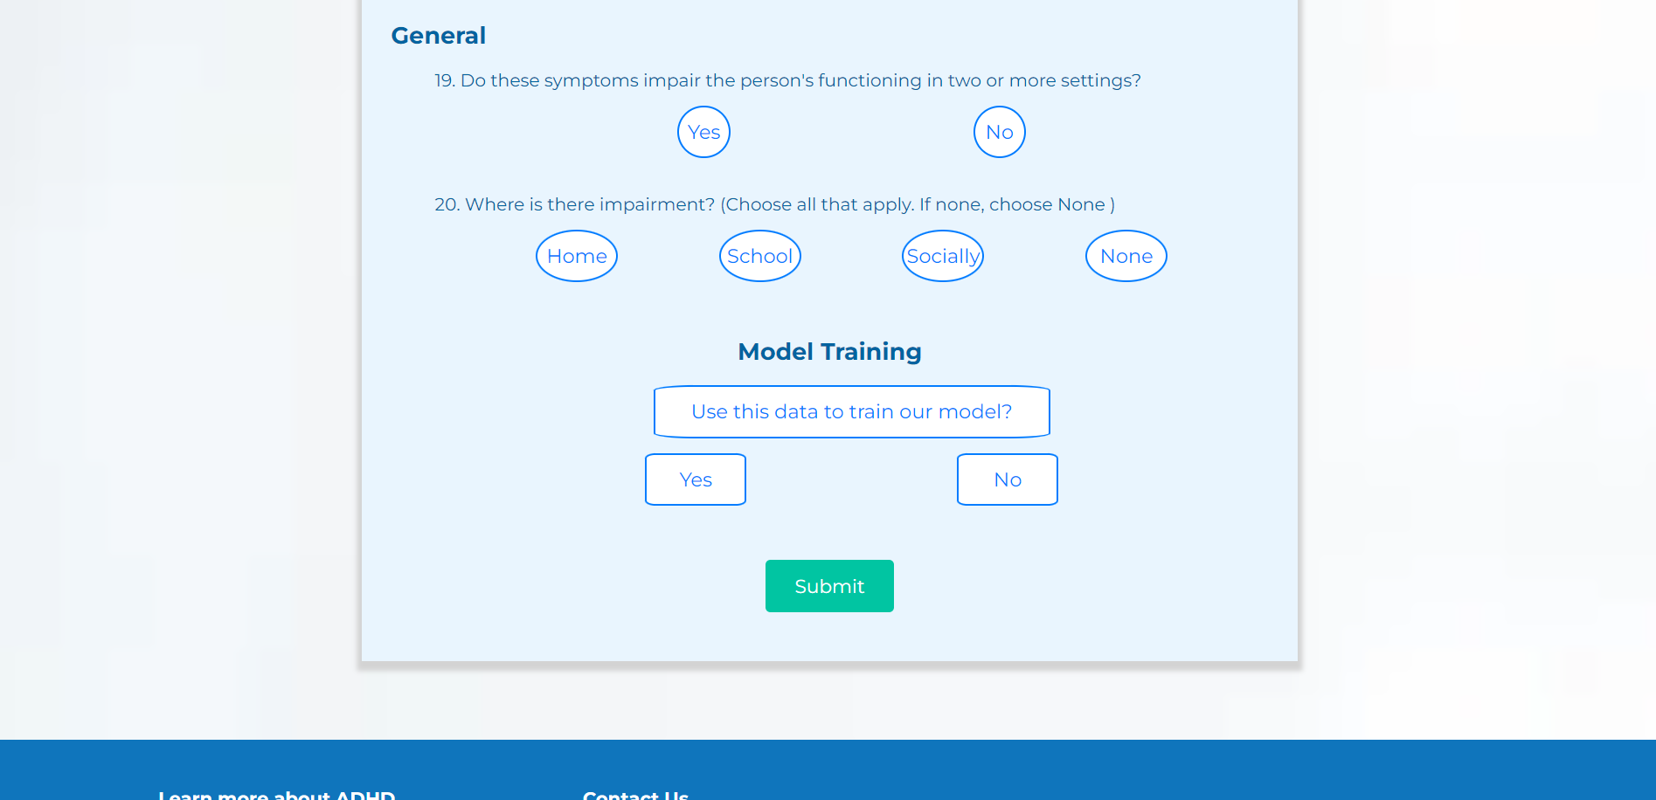

Once all questions have been answered, the user clicks the “Submit” button. The system will process the responses and incorporate them into the final evaluation.

**Important Note:** After submission, the user cannot change their answers. The system immediately begins processing the data to generate the results.

Input Fields and Actions:

* **Question Fields:** Each question requires a selection from multiple-choice options (0 to 3) or a Yes/No response.
* **Submit Button:** Finalizes the questionnaire and sends the responses for analysis.

Requirements:

The user must provide honest and accurate responses. The reliability of the overall assessment depends on the integrity of the data collected from this questionnaire.

# **5. Results Page**

This section involves 2 pages: the processing page and the results page. The processing page is called before the processing page and serves as a buffer that is shown to the user as our system analyzes the user’s test-results and prepares the final results page, this is page is static and does not allow the user to navigate back to any other page by normal means (excluding situations where the user manually closes the window or accesses another page by changing the URL). Here is what that page looks like:

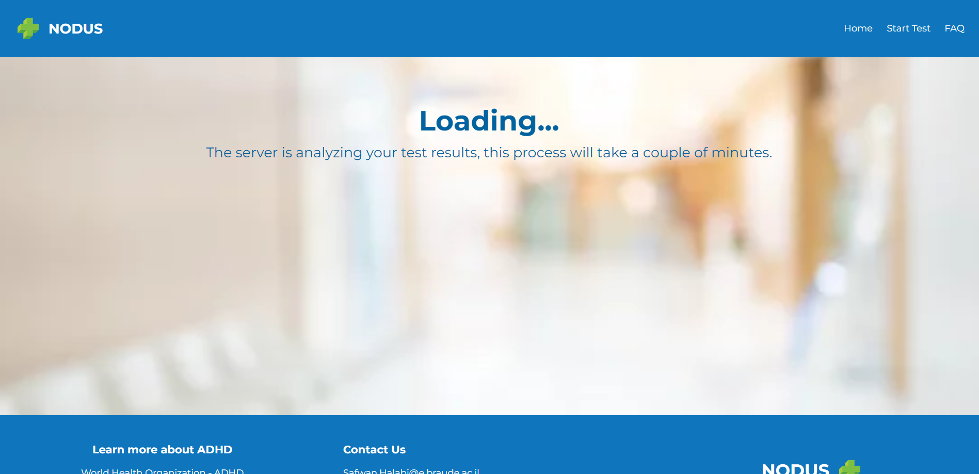

After going through the processing page the user will be greeted with the results page, which features a distribution of multiple ADHD subtypes and their respective percentages according to our model’s analysis and test-results, general tips to help the user deal with their detected subtype as well a button labeled “Back to homepage”, pressing said button will redirected to the homepage and all the data which was saved to our back-end will be flushed.

An image showing what the page looks like is provided on the next page.

This is what the page looks like:

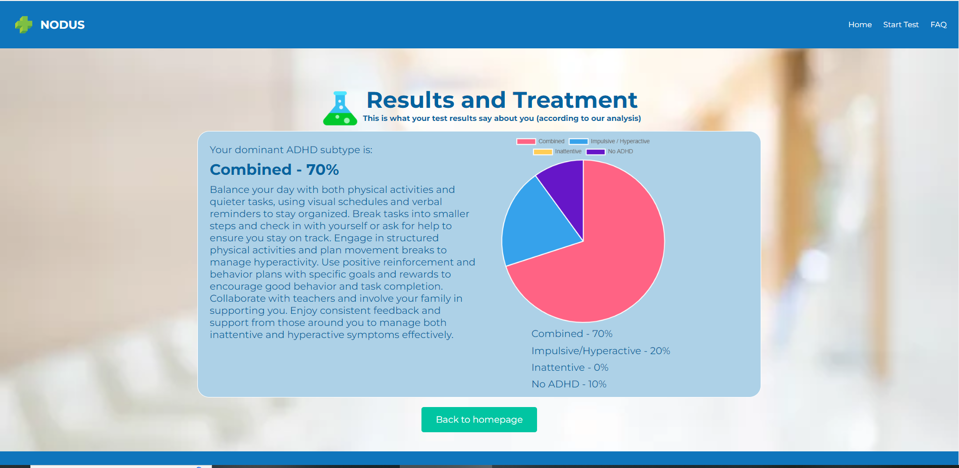

Input Fields and Actions:

* **Results Display:** Provides a visual and textual summary of the user’s ADHD classification.
* **Recommendations:** Offers personalized advice based on the user’s assessment.
* **Download Button:** Allows the user to save the results as a PDF.
* **Home Button:** Returns the user to the Homepage.

Requirements:

The user should carefully review the results and recommendations, no additional requirements are needed for this page.